Musculoskeletal Physiotherapy Sheet
- Patient Interview
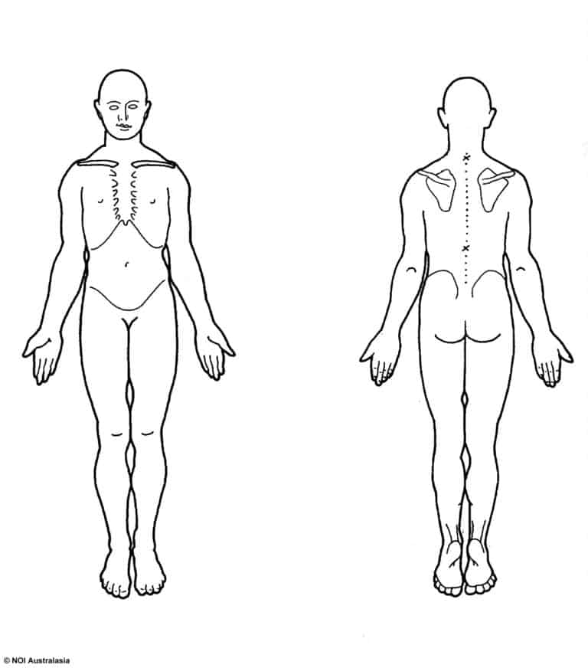 | Date:………………………………………………….  Physiotherapist:…………………………………..  Personal Information:  Patient Name:……………………………………...  DOB/Age:…………………………………………….  Occupation:…………………………………………
Pain Level (VAS or NRS):
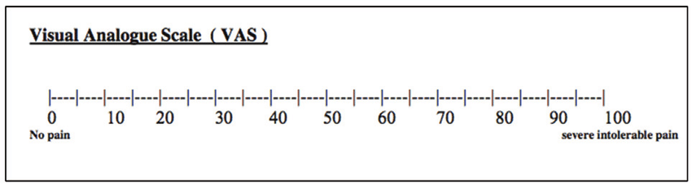
Present History:  Chief Complaint:  Onset:  Mechanism of injury: | 24 hours Pattern:  S  I  N  Sleep pattern/Disturbance:  Aggregating factors:  Easing Factors:
Medical History:  Previous surgeries:  Current medications:  Family medical history: | Social History:  Occupational Activities:  Living arrangement:  Level of Activity:  Smoking/Alcohol:
Diagnostic Imaging (if any):

Red Flags Screening:

Patient Expectations:

Short-Term Goals:

Long-Term Goals

Clinical Reasoning
Structural Approach:
Bone | Muscle | Nerve | Other

Must | Should | Could

Working Hypotheses:
1-
2-
3-
- Objective Assessment
Observation:
Range of Motion: | Active:  Passive:  Accessory:
Strength Testing:
Neurological Assessment | Dermatomes:  Myotomes:  Reflexes:  UMN:  Peripheral Nerves Neurodynamics:
Muscle Length:

Functional Assessment:

Palpation:

Special Testing:

Outcome Measures:

- Treatment Plan

- Education: | Suggested topics  - Condition and stage of healing  - Pain  - How to relieve the pain  - Functional and ADL advice  - Ergonomic Advice  - Return to work/Sport plan  - Surgery  - Electrotherapy and US  - Value of Exercise  - Kinesiophobia
- Therapeutic Exercise (Dosage: Repetitions and Sets)  Progression  Regression | 1-  2-  3-  4-
- Manual Therapy | 1-  2-  3-
- Adjuncts

- Discharge
Indications of discharge:

